

Emergency Patient Queue Management System
Submitted in the partial fulfilment for the Course of

CSA0311- Data Structures
to the award of the degree of
BACHELOR OF ENGINEERING
IN

B. TECH -AIDS

Submitted by
P ROHINI (192524147)
Under the Supervision of Dr. K. Kiruthika

Saveetha School of engineering
Saveetha Institute of Medical and Technical Sciences
Chennai-602105
September 2026
COMMON COURSE ASSIGNMENT FORMAT
A. Assignment Information

Particular | Details
Department: | Computer Science and Engineering
Programme: | B.Tech
Course Code & Course  Name | CSA0307 Data Structure
Academic Year / Batch | 2nd year (2025-2029)
Faculty Name | Dr.K.Kiruthika
Assignment Title | Design a smart-city emergency routing system with 50+intersections (Nodes) and 100 +weighted roads (Edges and Weights).
Date of Issue | 31-08-2026
Date of Submission | 02-09-2026
Maximum Marks | 100
Course Outcome(s) – CO | CO2: Apply the suitable Abstract Data type for construction of the smart city emergency system  CO4: Make use of heaps, priority queue and hashing techniques for graph storage and route cache for repeated queries in C.  CO5: Develop robust emergency patient management system by implementing priority-based scheduling and analyzing performance and complexity.
Bloom's Taxonomy Level | L4 – Analyze
SDG Mapping (SDG 1-17) | SDG-3 and SDG-9
Industry / Societal  Relevance | SDG 3 – Good Health and Well-being; SDG 9 – Industry, Innovation, and Infrastructure

B. Assignment Problem / Challenge

Design a hospital Emergency Department Patient Queue Management System that receives patient information containing patient ID, arrival time, severity level, and assigned doctor, and uses suitable data structures to ensure critically ill patients are treated first while maintaining FIFO order among patients with the same severity level. Compare alternative data structures and justify the final engineering solution based on performance, memory usage, scalability, fairness, and correctness.C. Problem Statement
Problem / Case / Design Challenge:

A hospital emergency department receives patients continuously throughout the day, and each patient may require a different level of medical attention depending on the severity of their condition. For every patient, the system needs to maintain important information such as a unique patient ID, arrival time, severity level, and assigned doctor. Patients with critical or life-threatening conditions must be given higher priority and treated before patients with less severe conditions. However, when two or more patients have the same severity level, they should generally be treated in the order in which they arrived at the emergency department, following the First-In-First-Out (FIFO) principle within the same priority level. As the number of patients may increase rapidly, the hospital requires an efficient data-structure-based solution for registering new patients, assigning priorities, selecting the next patient for treatment, updating patient information, and removing patients after treatment. Students has to design and implement an appropriate data structure for managing the emergency patient queue by evaluating the suitability of a simple queue, array, linked list, priority queue, or another suitable data structure. Justify the selection of the most appropriate data structure based on the requirements of priority-based treatment and arrival-order processing. Clearly describe the major operations involved, including patient insertion, priority assignment, identifying the next patient for treatment, deletion of treated patients, searching for a particular patient, and updating patient or doctor information. Analyze the time and space complexity of these operations in the best-case, average-case, and worst-case scenarios wherever applicable. In addition, critically discuss the limitations and possible problems that could occur if a conventional FIFO queue were used instead of a priority-based data structure. Explain how using a simple FIFO queue could cause critically ill patients to wait behind patients with less severe conditions, potentially resulting in delayed treatment and serious consequences. Finally, explain how the selected data structure can improve the efficiency, fairness, responsiveness, and reliability of patient management in a busy hospital emergency department.

D. Requirements and Constraints

Functional: Register patients and find the next patient to be treated based on severity and FIFO tie-break.

Performance: Support fast operations under heavy patient arrival rates.

Technical: Use priority queue / heap; maintain FIFO within each severity level; support search/update using hashing if needed.

Safety: Ensure critical patients are not delayed behind low-severity patients.

Reliability: Maintain correct ordering despite updates to severity and doctor assignment.

User: Simple interface to register, update, search and treat patients.

Security: Protect patient/doctor data and access.

Cost: Use low-cost/free software and tools.

E. Student Work

1. Problem Understanding and Formulation
1.1 What is the problem?

In a hospital emergency department, patients arrive continuously and must be treated based on how severe their condition is. A normal FIFO queue is not sufficient because it would treat patients only by arrival time. Critical patients must be treated first. At the same time, if multiple patients have the same severity, fairness requires FIFO ordering among them. Therefore, the emergency queue must support both priority ordering and FIFO tie-breaking.

1.2 Expected outcomes

Find the next patient for treatment based on highest severity.
Follow FIFO order for patients with the same severity.
Register new patients efficiently.
Assign and update patient severity level and doctor information.
Remove patients after treatment.
Search for a particular patient by patient ID.
Display patient order and basic queue statistics.
Compare simple FIFO queue vs priority-based approach.

1.3 Available information/data
Data | Description
Patient ID | Unique identifier for each patient
Arrival Time | Time when the patient arrives (or a sequence number)
Severity Level | CRITICAL / HIGH / MEDIUM / LOW (or equivalent)
Assigned Doctor | Doctor assigned for patient treatment
Status | Waiting / Treated / Removed

1.4 Assumptions

- Severity levels are predefined and ordered by medical urgency.
- Arrival time is recorded correctly and used for FIFO within a severity level.
- Patient ID is unique.
- Severity can change after triage or due to condition change.
- Doctor assignment can be updated.
- Treated patients are removed from the queue.

1.5 Constraints

- The number of patients can increase rapidly.
- Priority selection must be fast and correct.
- Updates must be supported without breaking queue order.
- Memory usage should remain moderate.

2. Application of Course Knowledge

2.1 Graph Data Structure

The patient management system is represented as a priority-based queue structure:
- Each patient is a record containing:
  - Patient ID
  - Arrival time / sequence
  - Severity level (priority)
  - Assigned doctor
To enforce both rules:
- Higher severity patients should be selected first (priority rule).
- Within same severity, earlier arrivals first (FIFO tie-break rule).
This can be implemented using:
- A Priority Queue (Heap) ordered by (severityRank, arrivalOrder)
and optionally
- A Hash Table mapping patientID → patient record for fast search/update.

2.2 Priority Queue / Heap

A heap-based priority queue is used to always select the patient with the highest severity efficiently.
- Insert patient into heap.
- Extract highest priority patient for treatment.
- Tie-break using arrival order to preserve FIFO within the same severity.

2.3 Hashing for Search and Update
Hashing can be used to support:
- O(1) average search for a patient by patient ID.
- Efficient updates to assigned doctor or severity.
- Removal of treated patients from records.

2.4 Complexity

For heap-based priority queue operations:
- Insert: O(log n)
- Extract next: O(log n)
- Peek next: O(1)
Hash table operations (average):
- Search: O(1)
- Update: O(1)

3. Solution / Design / Methodology

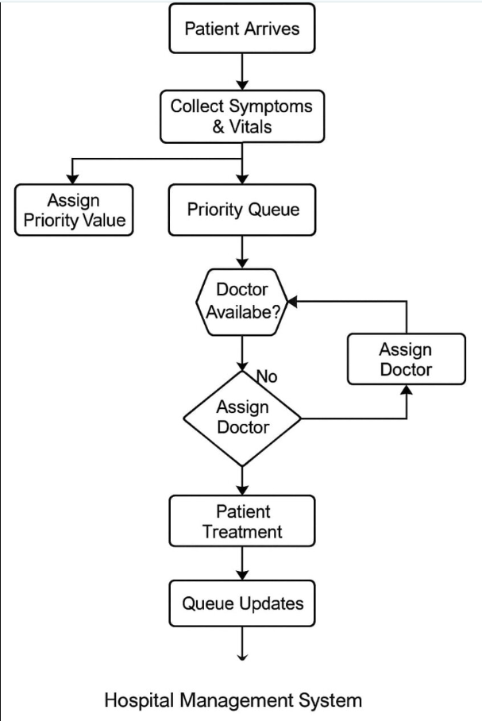

4. Use of Modern Tools

Tool/Library | Purpose
C | Main programming language
Priority Queue / Heap | Efficient priority-based patient selection
Hash Table | Fast search and update by patient ID
time | Execution-time measurement (optional testing)
Structs & pointers | Patient record storage and manipulation

5. Results and Validation
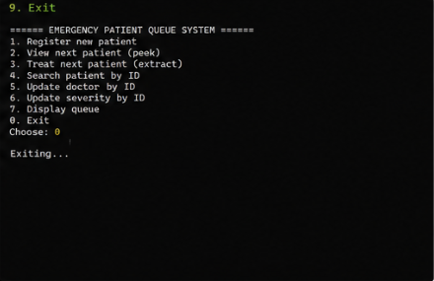

Source Code:

#include <stdio.h>
#include <string.h>

#define MAX_PATIENTS 1000

// Severity ranking: higher number => higher priority
// CRITICAL=4, HIGH=3, MEDIUM=2, LOW=1

typedef struct {
int patientId;
int severity; // 1..4
long arrivalSeq; // increasing sequence to preserve FIFO
char doctor[50];
} Patient;

typedef struct {
Patient heap[MAX_PATIENTS];
int size;
long nextArrivalSeq;
} PriorityQueue;

// ---------- Utility ----------
const char* severityName(int sev) {
switch (sev) {
case 4: return "CRITICAL";
case 3: return "HIGH";
case 2: return "MEDIUM";
case 1: return "LOW";
default: return "UNKNOWN";
}
}

// Return 1 if a has higher priority than b
// Priority rule: higher severity first; if equal severity, smaller arrivalSeq first (FIFO)
int higherPriority(Patient a, Patient b) {
if (a.severity != b.severity) return a.severity > b.severity;
return a.arrivalSeq < b.arrivalSeq;
}

// ---------- Heap Functions ----------
void pqInit(PriorityQueue *pq) {
pq->size = 0;
pq->nextArrivalSeq = 1;
}

void swapPatients(Patient *a, Patient *b) {
Patient temp = *a;
*a = *b;
*b = temp;
}

void heapifyUp(PriorityQueue *pq, int idx) {
while (idx > 0) {
int parent = (idx - 1) / 2;
if (higherPriority(pq->heap[idx], pq->heap[parent])) {
swapPatients(&pq->heap[idx], &pq->heap[parent]);
idx = parent;
} else {
break;
}
}
}

void heapifyDown(PriorityQueue *pq, int idx) {
while (1) {
int left = 2 * idx + 1;
int right = 2 * idx + 2;
int best = idx;

if (left < pq->size && higherPriority(pq->heap[left], pq->heap[best])) best = left;
if (right < pq->size && higherPriority(pq->heap[right], pq->heap[best])) best = right;

if (best != idx) {
swapPatients(&pq->heap[idx], &pq->heap[best]);
idx = best;
} else {
break;
}
}
}

int pqInsert(PriorityQueue *pq, int patientId, int severity, const char *doctor) {
if (pq->size >= MAX_PATIENTS) return 0;

Patient p;
p.patientId = patientId;
p.severity = severity;
p.arrivalSeq = pq->nextArrivalSeq++;
strncpy(p.doctor, doctor, sizeof(p.doctor) - 1);
p.doctor[sizeof(p.doctor) - 1] = '\0';

pq->heap[pq->size] = p;
heapifyUp(pq, pq->size);
pq->size++;
return 1;
}

int pqIsEmpty(PriorityQueue *pq) {
return pq->size == 0;
}

Patient pqPeek(PriorityQueue *pq) {
return pq->heap[0];
}

Patient pqExtractMax(PriorityQueue *pq) {
Patient top = pq->heap[0];
pq->size--;
if (pq->size > 0) {
pq->heap[0] = pq->heap[pq->size];
heapifyDown(pq, 0);
}
return top;
}

// ---------- Search / Update (simple linear; can be replaced by Hash Table) ----------
int findIndexByPatientId(PriorityQueue *pq, int patientId) {
for (int i = 0; i < pq->size; i++) {
if (pq->heap[i].patientId == patientId) return i;
}
return -1;
}

int updateDoctor(PriorityQueue *pq, int patientId, const char *newDoctor) {
int idx = findIndexByPatientId(pq, patientId);
if (idx == -1) return 0;
strncpy(pq->heap[idx].doctor, newDoctor, sizeof(pq->heap[idx].doctor) - 1);
pq->heap[idx].doctor[sizeof(pq->heap[idx].doctor) - 1] = '\0';
return 1;
}

int updateSeverity(PriorityQueue *pq, int patientId, int newSeverity) {
int idx = findIndexByPatientId(pq, patientId);
if (idx == -1) return 0;

int oldSeverity = pq->heap[idx].severity;
pq->heap[idx].severity = newSeverity;

// Severity change may violate heap property; fix by moving up or down
if (newSeverity > oldSeverity) heapifyUp(pq, idx);
else heapifyDown(pq, idx);

return 1;
}

void printQueue(PriorityQueue *pq) {
printf("\n--- CURRENT WAITING LIST (Heap order) ---\n");
printf("ID\tSeverity\tArrivalSeq\tDoctor\n");
for (int i = 0; i < pq->size; i++) {
printf("%d\t%s\t\t%ld\t\t%s\n",
pq->heap[i].patientId,
severityName(pq->heap[i].severity),
pq->heap[i].arrivalSeq,
pq->heap[i].doctor);
}
printf("----------------------------------------\n");
}

// ---------- Menu ----------
void menu() {
printf("\n====== EMERGENCY PATIENT QUEUE SYSTEM ======\n");
printf("1. Register new patient\n");
printf("2. View next patient (peek)\n");
printf("3. Treat next patient (extract)\n");
printf("4. Search patient by ID\n");
printf("5. Update doctor by ID\n");
printf("6. Update severity by ID\n");
printf("7. Display queue\n");
printf("0. Exit\n");
printf("Choose: ");
}

int main() {
PriorityQueue pq;
pqInit(&pq);

int choice;
while (1) {
menu();
if (scanf("%d", &choice) != 1) break;

if (choice == 0) {
printf("Exiting...\n");
break;
}

if (choice == 1) {
int id, sev;
char doc[50];
printf("Enter Patient ID: ");
scanf("%d", &id);
printf("Enter Severity (4=CRITICAL, 3=HIGH, 2=MEDIUM, 1=LOW): ");
scanf("%d", &sev);
printf("Enter Assigned Doctor: ");
scanf(" %49[^\n]", doc);

if (sev < 1 || sev > 4) {
printf("Invalid severity!\n");
} else if (pqInsert(&pq, id, sev, doc)) {
printf("Patient registered successfully.\n");
} else {
printf("Queue full! Cannot insert.\n");
}
}
else if (choice == 2) {
if (pqIsEmpty(&pq)) {
printf("No patients waiting.\n");
} else {
Patient p = pqPeek(&pq);
printf("Next Patient: ID=%d, Severity=%s, Doctor=%s\n",
p.patientId, severityName(p.severity), p.doctor);
}
}
else if (choice == 3) {
if (pqIsEmpty(&pq)) {
printf("No patients waiting.\n");
} else {
Patient p = pqExtractMax(&pq);
printf("Treated Patient: ID=%d, Severity=%s, Doctor=%s\n",
p.patientId, severityName(p.severity), p.doctor);
}
}
else if (choice == 4) {
int id;
printf("Enter Patient ID to search: ");
scanf("%d", &id);
int idx = findIndexByPatientId(&pq, id);
if (idx == -1) {
printf("Patient not found.\n");
} else {
Patient p = pq.heap[idx];
printf("Found: ID=%d, Severity=%s, ArrivalSeq=%ld, Doctor=%s\n",
p.patientId, severityName(p.severity), p.arrivalSeq, p.doctor);
}
}
else if (choice == 5) {
int id;
char doc[50];
printf("Enter Patient ID: ");
scanf("%d", &id);
printf("Enter New Doctor: ");
scanf(" %49[^\n]", doc);

if (updateDoctor(&pq, id, doc)) printf("Doctor updated.\n");
else printf("Patient not found.\n");
}
else if (choice == 6) {
int id, sev;
printf("Enter Patient ID: ");
scanf("%d", &id);
printf("Enter New Severity (4..1): ");
scanf("%d", &sev);

if (sev < 1 || sev > 4) {
printf("Invalid severity!\n");
} else if (updateSeverity(&pq, id, sev)) {
printf("Severity updated and queue reordered.\n");
} else {
printf("Patient not found.\n");
}
}
else if (choice == 7) {
printQueue(&pq);
}
else {
printf("Invalid choice.\n");
}
}
return 0;
}
Test Cases:
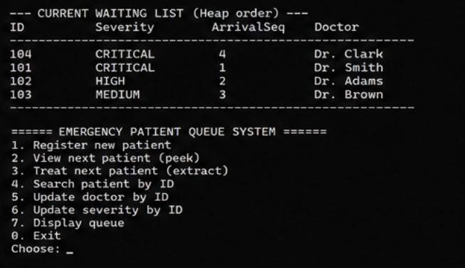

•

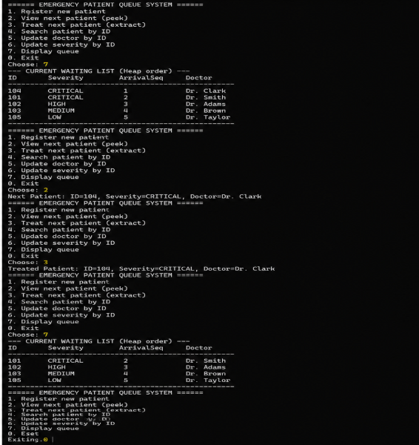

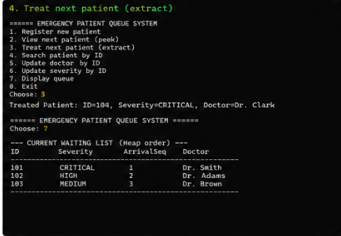
6. Analysis and Engineering Decision

Final Engineering Decision
Priority Queue (Heap) with FIFO tie-breaking was selected because the emergency department requires severity-based treatment with fairness among same-severity patients.
A conventional FIFO queue is less suitable because it may force critical patients to wait behind less severe cases.
A simple linked list or array-based sorted structure can maintain order but becomes inefficient for large numbers of patients due to O(n) insertion.
Therefore, heap-based priority queue provides the best balance between correctness, efficiency and scalability. Hashing improves search and update performance.

Algorithm Comparision

Algorithm | Advantage | Limitation | Suitability
FIFO Queue | Very simple | Cannot prioritize critical patients | Low
Sorted Array | Maintains priority order | Insertion O(n) | Medium
Priority Queue (Heap) | Insert/Remove O(log n), Peek O(1) | Severity update requires heap adjustment | High

7. Broader Considerations

7.1 Safety

Prioritizing critical patients can reduce waiting time for life-threatening conditions and improve patient outcomes.

7.2 Society

Efficient emergency department flow improves healthcare service quality for the community.

7.3 Environment

Reduced patient waiting and optimized doctor assignment can reduce congestion in emergency facilities and resource waste.

7.4 Economics

Efficient patient management improves utilization of doctors and beds and reduces operational inefficiency.

7.5 Professional Responsibility

Because emergency patient handling is safety-critical, real-world deployment requires validation, auditing, privacy protections, and reliable triage processes.

8. Conclusion
The Emergency Department Patient Queue Management System demonstrates how Data Structures support safety-critical hospital operations. The system uses priority-based scheduling to treat higher severity patients first while preserving FIFO order within the same severity level. A heap-based priority queue provides efficient insertion and extraction, while hashing can enable fast searching and updating of patient records. Compared to a conventional FIFO queue, the chosen design improves responsiveness, fairness, and reliability in a busy emergency department.
The project achieves its main objective of demonstrating dynamic weighted shortest-path routing for emergency vehicles. However, future versions could integrate real-time GPS/traffic APIs, larger road networks, live vehicle tracking and more advanced routing techniques.

9. Student Reflection

Through this assignment, I learned how data-structure selection affects real-world safety and fairness. I gained understanding of priority queues, heap operations, FIFO tie-breaking, hashing for fast lookup, and complexity analysis. I also learned why a FIFO queue alone is insufficient for emergency patient management where medical urgency must take priority.

10. References
[1] Thomas H. Cormen, Charles E. Leiserson, Ronald L. Rivest, and Clifford Stein, Introduction to Algorithms, Priority Queues and Heaps.
[2] Data Structures in C: Priority Queue and Hash Table implementations (course notes).
[3] General emergency department triage principles (severity-based prioritization).

- Python Software Foundation, “tkinter — Python interface to Tcl/Tk,” Python 3.14
Documentation, 2026. [Online]. Available: Python Tkinter Documentation

- NetworkX Developers, “NetworkX: Graph types and algorithms,” NetworkX 3.4
Documentation, 2024. [Online]. Available: NetworkX Reference Documentation

- Python Software Foundation, “Python 3.12 Documentation,” Python Documentation, 2023. [Online]. Available: Python 3.12 Documentation

- Python Software Foundation, “Python 3.13 Documentation,” Python Documentation, 2024. [Online]. Available: Python 3.13 Documentation

- NetworkX Developers, “NetworkX algorithms,” NetworkX Documentation, 2024. [Online]. Available: NetworkX Algorithms

- Python Software Foundation, “Data structures — Lists, sets and dictionaries,” Python 3
Documentation, 2026. [Online]. Available: Python Data Structures Documentation

- Python Software Foundation, “Graphical user interface FAQ,” Python Documentation, 2026. [Online]. Available: Python GUI Documentation

- Common Assessment Rubric

Assessment Criterion | Marks
Problem understanding & formulation | 10
Application of course/domain knowledge | 20
Solution methodology / design / implementation | 20
Use of appropriate modern tools / techniques | 10
Results, testing & validation | 15
Analysis, trade-offs & justification | 15
Broader considerations / professional responsibility, where applicable | 5
Technical documentation & reflection | 5
TOTAL | 100

- CO–PO–Assessment Mappin

Assessment Component | CO | PO(s) | Bloom's Level | Marks
Problem formulation |  |  | L3/L4 | 10
Application of knowledge |  |  | L3/L4 | 20
Solution / Design / Implementation |  |  | L4/L5/L6 | 20
Modern tool usage |  |  | L3/L4 | 10
Validation |  |  | L4/L5 | 15
Analysis & justification |  |  | L4/L5 | 15
Broader considerations |  |  | L4/L5 | 5
Documentation & reflection |  |  | L3/L4 | 5
Note: Faculty shall map only the POs and Bloom's levels genuinely assessed by the particular assignment. Every assignment is not required to map to every PO.
- Faculty Evaluation & Continuous Improvement CO
Attainment
Performance Level | Criterion
Level 3 | ≥ 70%
Level 2 | 60–69%
Level 1 | 50–59%
Level 0 | < 50%
Target CO Attainment:
Actual CO Attainment:

Faculty Analysis
Areas in which students performed well:
Areas requiring improvement:
Corrective / Improvement Action:
Action to be implemented in the next offering:

Documents to be Maintained

The department/course faculty shall maintain:

- Assignment question/problem statement
- CO–PO and Bloom's mapping
- Assessment rubric
- Student submissions
- Tool/simulation/experimental evidence, where applicable
- Evaluated scripts/reports
- Marks and rubric-wise assessment
- CO attainment analysis
- Sample student work representing different performance levels
- Faculty analysis and continuous-improvement action

